- BACKGROUND
- RATIONALE
- RAISING STANDARDS
- CONSISTENCY OF PRACTICE
- GENERAL ADVICE
- EVALUATION

- Background
Oswaldtwistle School is a short stay school. Most of our students have experienced difficulty coping in their mainstream school in terms of either their behaviour or emotional state. Whether they have been permanently excluded, are on an intervention placement from mainstream or have been referred to us through the East Lancashire Child and Adolescent Service.
Our students often have ‘gaps’ in their basic skills and require focused work on Numeracy to ensure that they are able to achieve their potential. Our aim is to support them to overcome their difficulties and successfully access continuing education, training or employment post 16, thus markedly improving their life chances.

- Rationale
The new 1-9 GCSE in Mathematics has become far more demanding, even at Foundation Tier. In a government press release it was stated that, “Grade 5 will be positioned in the top third of the marks for a current Grade C and bottom third of the marks for a current Grade B. This will mean it will be of greater demand than the present grade C, and broadly in line with what the best available evidence tells us is the average PISA performance in countries such as Finland, Canada, the Netherlands and Switzerland”.
Furthermore, the bottom Grades of G/F will now constitute a Grade 1.
Students will be expected to apply Mathematical concepts in ‘unfamiliar’ settings. This will draw on cross-curricular links throughout the school and their success in doing so, rely on the quality of delivery of Mathematical concepts within other subject areas.

- Raising Standards
In order to raise standards of Numeracy across the school, we aim to target two main areas during wave 1 of our Intervention.

Basic Numeracy Skills
Improvement of basic Numeracy skills will be addressed initially through form time intervention. All pupils will take part in the ‘Numeracy Ninjas’ project. They will have 3 sessions of dedicated Numeracy practice per week. Form tutors will facilitate this, Alison Ashton (Lead Teacher - Mathematics) will monitor pupil progress via a record sheet completed by form tutors. Students will be rewarded for their progress through the project.
Alison Ashton will ensure that common misconceptions across groups of students are addressed and appropriate intervention is delivered. The impact of this intervention will be evaluated.

Skills transfer
All staff will ensure that opportunities for Numeracy within their subject areas are highlighted on schemes of learning. They will also ensure that they are consistently using standard methods to deliver these concepts (see point 4 below). It is expected that staff will make reference to mathematical concepts / content within their subject area when teaching (where appropriate). Alison Ashton will make available skills posters specific to subject areas. These should be displayed within the classroom and referred to where appropriate.
All marking should ensure that calculations/ working out is corrected where appropriate and follows the numeracy policy.

- Consistency of Practice
It is the responsibility of EVERY member of staff to read the Standard Methods Booklet and ensure this is delivered within their subjects where appropriate. Staff should ensure that they are confident using these methods. Alison Ashton will provide on-going support throughout the year. She will provide Numeracy training sessions for those staff who require support / training to deliver standard methods successfully.
All parents/carers will also receive a booklet to help them support their child in using these methods while completing homework and revising for exams.
It is also expected that all staff will use and promote Mathematical Vocabulary when delivering Mathematical concepts. Key Words should be displayed and noted down by students. For example, it would be expected that students use subtract rather than takeaway, Multiply rather than times and where they don’t this is corrected by subject teachers.
Possible opportunities could include:
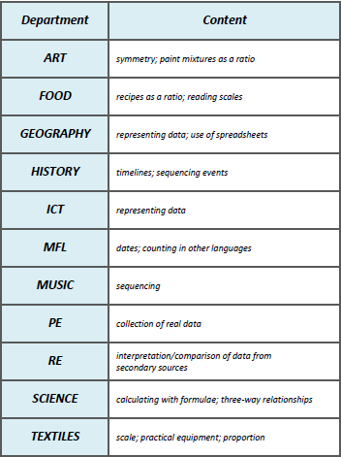

- General Advice
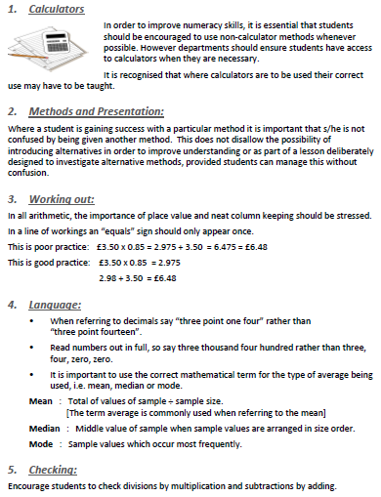

- Evaluation
 | ACTION | IMPACT | MEASURE
1 | All year groups to use Numeracy Ninja Booklets 3x per week during form time | Improved numeracy skills, independent learning skills and self-evaluation skills. | Pupil voice  Staff Voice  Data Sheet – Improved pupil outcomes
2 | FT to enter progress data into tracking sheet | Progress data can be tracked by AA  Areas of weakness identified | Data sheets completed  Intervention plan written  Staff Voice
3 | AA to review and appropriate intervention to take place | Analysis of data to identify areas of weakness  Intervention groups highlighted  Intervention plans in place – improved outcomes for pupils | Pupil Voice  Staff Voice  Data sheets - Improved scores
4 | Staff Numeracy hand books given to departments and made available on shared drive. Staff Training put in place by AA. | Staff self-evaluate training needs and target areas for improvement. Staff deliver lessons featuring the delivery of high quality numeracy opportunities | Lesson observation  Pupil Voice  Staff Voice
5 | Opportunities for Numeracy highlighted in Schemes of Learning (updated as they go) | Staff are able to plan appropriately for opportunities for numeracy within their day-to-day lessons  Students use standard methods across school | Schemes of Learning  Lesson Observation  Pupil Voice  Pupil workbooks
6 | Mathematical key words displayed and used in lessons where appropriate | Students draw links between Maths and other subjects  Mathematical vocabulary improved | Pupil Voice  Staff Voice  Pupil workbooks
7 | Marking focused on Numeracy – where appropriate | All calculations / working is corrected and appropriately set out | Pupil Voice  Pupil Workbooks

All areas will be reviewed and evaluated on a regular basis.

