Audience | Governors, staff, students, parents/carers
Review Cycle | 1 year
Current Review | September 2018
Next Review | September 2019
Staff Lead | Examinations Officer

Controlled Assessment, Coursework, Non-Examination Assessment and Portfolios of Evidence Policy
2018/2019

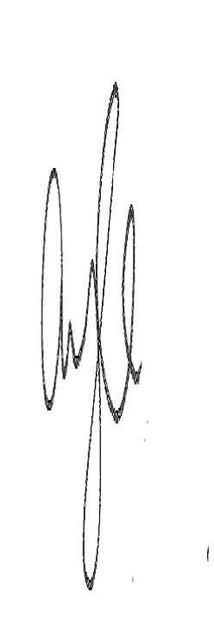
19.09.18

Table of contents
Purpose of the policy……………………………………………………………………………….2
Staff responsibilities in planning and managing GCSE non-examination assessments including controlled assessment, coursework and portfolios of evidence……………………………..……………………………………………………………….2
Risk management process…………………………………………………………………………3
Purpose of the policy
The purpose of this policy is to:
- Identify staff responsibilities in planning and managing GCSE non-examination assessments including controlled assessments, coursework and portfolios of evidence
- Identify potential risks and issues relating to the implementation of non-examination assessments including controlled assessments, coursework and portfolios of evidence for GCSE qualifications and how these might be managed and mitigated through forward planning and remedial actions.
This policy complies with JCQ’s General Regulations 5.8 in that the centre is required to “have in place, and be available for inspection purposes, a written policy with regard to the management of GCE and GCSE non-examination assessments;”

Staff responsibilities in planning and managing GCSE non-examination assessments including controlled assessment, coursework and portfolios of evidence
Senior Leadership Team
- Accountable for the safe and secure conduct of all non-examination assessments
- Ensure assessments comply with JCQ guidelines and awarding bodies’ subject-specific instructions
- At the start of the academic year, begin to coordinate with heads of department/subject teachers to schedule all non-examination assessments. It is advisable that non-examination assessments are spread throughout the academic years of Key Stage 4)
- Map overall resource management requirements for the academic year and resolve any:
- Clashes/problems over the timing or operation of non-examination assessments;
- Issues arising from the need for particular facilities (rooms, IT networks, time out of school etc.);
- Ensure that the EO is informed of all scheduled non-examination assessments
- Circulate scheduled non-examination assessments to all staff involved

Head of department/subject teacher
- Decide on the awarding body and specification for a particular GCE or GCSE qualification
- Standardise internally the marking of all teachers involved in assessing an internally assessed component
- Ensure that individual teachers fully understand their responsibilities with regard to non-examination assessments, including controlled assessment, coursework and portfolios of evidence
- Ensure that individual teachers fully understand the requirements of the awarding body’s specification, are familiar with the relevant teachers’ notes and any other subject specific instructions
- Where appropriate, develop new assessment tasks or adapt sample awarding body assessment tasks to meet local circumstances, in line with the awarding body’s specification and control requirements
Teaching Staff
- Understand and comply with the general guidelines detailed in the JCQ publication Instructions for conducting non-examination assessments
- Understand and comply with the awarding body’s specification for conducting non-examination assessments, including any subject-specific instructions, teachers’ notes or additional information on the awarding body’s website
- Supply the EO with details of all unit codes for non-examination assessments
- Obtain confidential materials/tasks set by awarding bodies in sufficient time to prepare for the assessment(s) and ensure that such materials are stored securely at all times
- Supervise assessment(s) at the specified level of control. Undertake the tasks required under the regulations, only permitting assistance to candidate as the specification allows
- Ensure that candidates and supervising teachers sign authentication forms on completion of a non-examination assessment
- Mark internally assessed components using the mark scheme provided by the awarding body.
- Submit marks to the awarding body by the published deadline, keeping a record of the marks awarded
- Liaise with the EO if login details are required for the awarding bodies secure portal
- Retain candidates’ work securely between assessment sessions (if more than one)
- Post-completion, retain candidates’ work securely until the closing date for enquiries about results. In the event that an enquiry is submitted, retain candidates’ work securely until the until the outcome of the enquiry and any subsequent appeal has been conveyed to the centre
- Ask the appropriate special educational needs co-ordinator (SENCO) for any assistance required for the administration and management of access arrangements

Exams officer
- Where confidential materials are directly received by the exams office, to be responsible for receipt, safe storage and safe transmission, whether in CD or hard copy format
- Download and distribute mark sheets for teaching staff to use
- In exceptional circumstances where all non-examination assessments cannot be conducted in the classroom, arrange suitable accommodation where all non-examination assessments can be carried out at the direction of the senior leadership team
Special educational needs co-ordinator (SENCO)
- Ensure access arrangements have been applied for
- Work with teaching staff to ensure requirements for support staff are met

