Homeostasis and Response notes:

Homeostasis is _________________________________________________________________

Solve the anagrams to find the things kept steady by homestasis:

Cubed Solo Log ________________________ Adey boer trumpet _______________________________
earls twelve ________________________________

What happens if conditions are not right (35 seconds on the first video)

Nervous System
Label the diagram
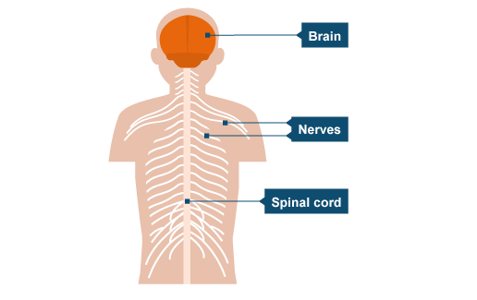

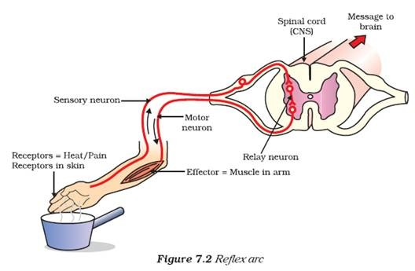

Endocrine System
Use the keywords to label the reflex arc:
- Sensory neurone
- Spinal cord (CNS)
- Relay neurone
- Message to the brain
- Receptors in the skin (heat and pain)
- Effector (muscle in the arm)
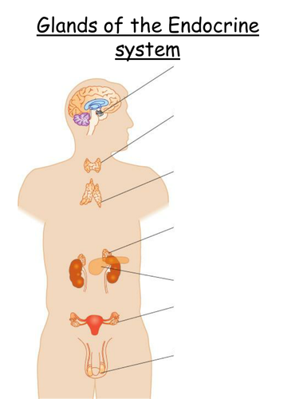Label the glands.
Pancreas
Testes
Ovaries
Thyroid gland
Adrenal Gland
Pituitary gland

