Bonding and the properties of matter
States of matter
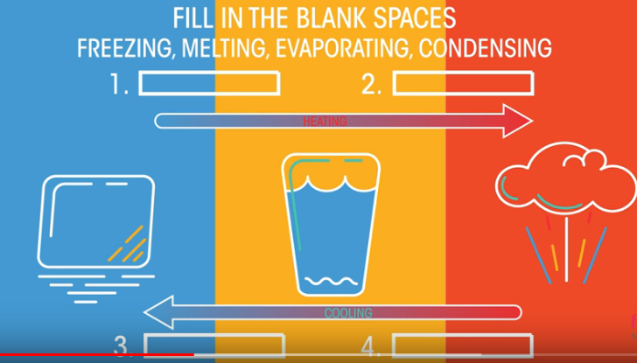
Label the diagrams Solid, Liquid and Gas
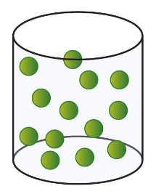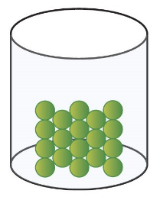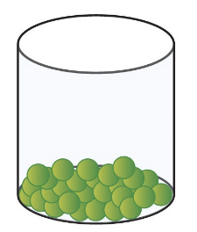
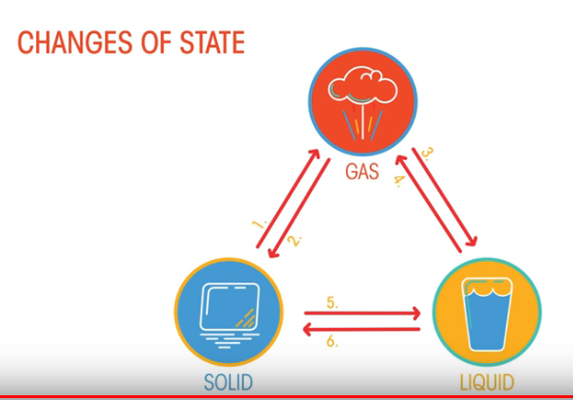
1___________________________
2___________________________
3___________________________
4___________________________
5___________________________
6___________________________

 | High melting point | Low melting point | Soluble in water (usually) | Solid conducts electricity | Liquid conducts electricity
Metal | Some | Some | No | Yes | yes
Ionic compound
Simple covalent compound
Polymer
Fill in the table

