Electron Configuration
12
6
C
Proton number

Mass Number

¹⁸
Electron structure for Argon: (₄₀Ar)
Ignore the mass number – we’re not interested in it for now.

Proton number is 18
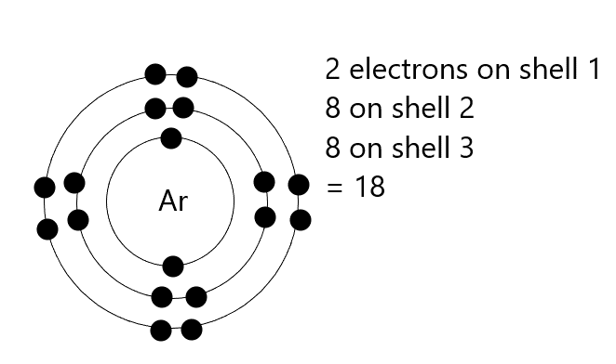
Configuration 2 . 8 . 8

⁶
Draw the electron structure of Carbon (₁₂C)

Write down the configuration (electrons in each shell starting from the inside)

